**Print a tree like structure as shown below:**

**If we enter:**

if __name__ == '__main__':

    root = buid_management_team()

    root.print_tree('both')

**Print:**

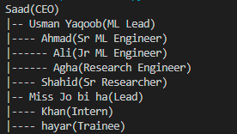

**And If we enter:**

if __name__ == '__main__':

    root = buid_management_team()

    root.print_tree('name')

**Print:**

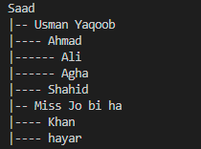

**And If we enter:**

if __name__ == '__main__':

    root = buid_management_team()

    root.print_tree('designation')

**Print:**

